**Title: Synchronizing Google Calendar for University Academic Calendar Management**

**Issued by:** Ahmedabad University  
**Department:** Academic Registrar & IT  
**Date:** [08/03/2025]

### ****1. Purpose****

This document outlines the procedure for setting up a Google Calendar to manage the academic calendar. This will allow students, faculty, and staff to access and stay updated on important academic events and schedules.

### ****2. Steps for Creating and Configuring Google Calendar****

#### ****Step 1: Create a New Calendar****

1. Log in to Google Workspace using admin credentials.
2. Open Google Calendar.
3. On the left panel, click on the “+” next to “Other calendars.”
4. Select “Create new calendar.”
5. Enter the following details:
   * **Calendar Name:** Academic Registrar
   * **Description:** Official academic events, holidays, and schedules
6. Click “Create Calendar.”

#### ****Step 2: Configure Calendar Sharing Settings****

1. Go to “Settings” by clicking on the gear icon.
2. Select the newly created calendar from the left panel.
3. Under “Access permissions for events,” configure sharing options:
   * Enable “Make available for ahduni domain” to allow internal access.
   * Set appropriate visibility (e.g., “See all event details”).
4. Under “Share with specific people,” add authorized users (faculty, staff, or event coordinators) with edit permissions.
5. Click “Save.”

#### ****Step 3: Populate the Academic Calendar****

1. Import existing academic events:
   * If available, upload an academic calendar in CSV format using the “Import & export” option.
   * Manually add key academic events such as semester start and end dates, examination schedules, and holidays.

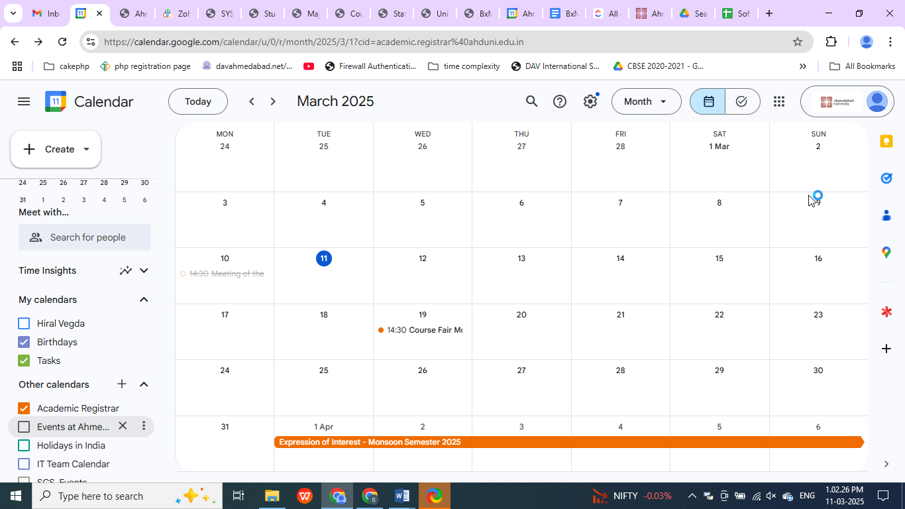

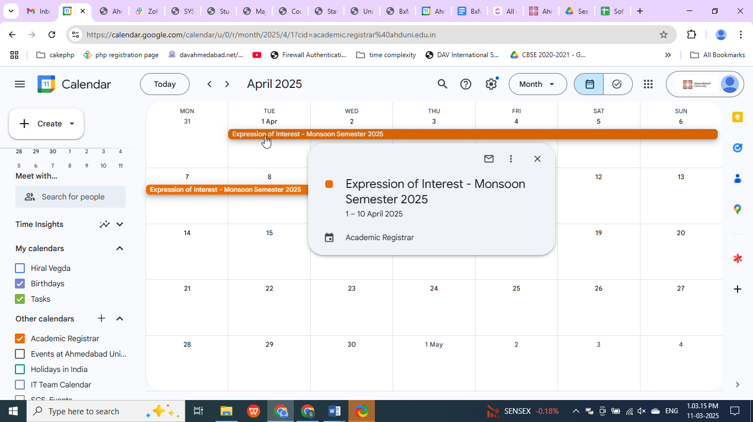

The events are added to the Academic Calendar by the office of the Academic Registrar.

1. Set event reminders and notifications as required.

### ****3. Maintenance and Management****

* Assign designated staff for periodic updates and management of calendar events.
* Review access permissions quarterly to ensure proper security.
* Communicate any major updates or changes to all stakeholders.

### ****4. Support and Contact****

Contact the Academic Registrar’s Office at academic.registrar@ahduni.edu.in for any issues or support.

Prepared by

Hiral Vegda (IT)